### *Introduction:*

### *This article is intended to offer extension some assistance with Inventory Management System (IMS) needs of a venture and discover a technique that addresses the issues of the task, and all gatherings included, without including undue managerial or specialized overhead, and that is (ideally) effective, easy to use, and secure.*

### *Purpose:*

### *The objective of this document is to describe the requirements of Inventory Management System. The target audience includes all the stakeholders involved in using this Management System who generally are Sales Person, Stock Person and Owner. It will give detailed description about the record of sale and purchase of Stock. Furthermore, the document will help to explain the features and interface of the system and a clear idea about the working of the system and the constraints under which the system will work.*

### *This archive is critical for both clients and temporary worker as far as the business point of view. Software Developers should take this record as the premise of the prerequisites of this venture. Everything written in this record is an obligatory prerequisite of this venture. They ought to likewise consider further corrections made to this record for development and better comprehension of the prerequisites. Aside from that, any verbal or composed articulation is not viewed as legitimate until and unless it is said in this record.*

### *Scope:*

### *The proposed software product is Inventory Management System (IMS) which is Stock Sal-Purchase Management System, offering services to the Business persons for handling the Sales in a feasible manner. The major component would be to offer a service that will provide feasible way to manage the stock through a proper computerized system. It will be designed to maximize the use of resources and time, by providing tools to scan item ID’s and generate bills, update Stock records, and see the availability status of the product etc. The application will be used to deliver services required for enhanced business.*

### *The multiple view system which will be helpful in the filtration of records would replace the manual work. By maximizing the resources and views, system will meet the needs of both Sales Person, Stock Person and Owner as well. More specifically, this system is designed to allow three different people related to the business, do their job by keeping the records synchronized.*

### *Definitions, Acronyms, and Abbreviations:*

### *IMS: Inventory Management System*

### *Make Sale: Making New Sale of the Stock.*

### *Desktop Application: an application that runs only on single Desktop.*

### *Sign up: Owner create an account to provide authorized access to the respective person on the Desktop application.*

### *User ID: a user identification to sign up.*

### *Password: A bunch of characters that enable a user to be authorized to enter the Desktop Application.*

### *SRS: Software Requirement Specification.*

### *User Stories:*

### 

### *1.1 Use Case #1*

### *Title: User Login*

### *Primary Actor: Owner / Sales Person / Stock Person*

### *Scenario: The user of the application must log in to view the respective details, like the Sales person must login in to fulfil his duties, stock person will also login to fulfil his duties and similarly the Owner to view the transaction history and provide authentication.*

### *Secondary Actor: Application*

### *Pre-Conditions:*

### *He must have an ID password to get access to the application.*

### *Basic Flow:*

### *He opens his panel.*

### *Enter his username and password.*

### *The database will authenticate that user.*

### *Now he will be able to do his work.*

### *Alternative Flow:*

### *In case, if the user enters invalid username or password, he has re-enter that.*

### *Post-Conditions:*

### *The user will be login to the system.*

### *1.2 Use Case #2*

### *Title: Make New Sale*

### *Primary Actor: Sales Person*

### *Scenario: The Sales Person will add the items to the application, and the quantity of the stock*

### *Secondary Actor: Application*

### *Pre-Conditions:*

### *Sale Person must be Login to the application.*

### *he must assure that stock is not empty.*

### *Basic flow:*

### *The Transaction ID will automatically be assigned to that sale.*

### *he will enter the product ID, name, quantity, and unit price.*

### *The system will add products to the cart and make total bill.*

### *Alternative flow:*

### *In case, if user enters the product that is not available into the stock.*

### *The system will signal user that product is not available.*

### *If user enters the quantity that is not sufficient, the system will signal user that quantity is large.*

### *Post-Conditions:*

### *System must calculate the total cost up till the products are added.*

### *System Must Generate Bills of the Sale.*

### 

### *1.3 Use Case #3*

### *Title: Add New Item*

### *Primary Actor: Stock Person*

### *Scenario: The Stock Person will add the information of the new items of the purchased stock to the application, and the quantity of the stock, and the relevant information of the new stock*

### *Secondary Actor: Application*

### *Pre-Conditions:*

### *Stock Person must be Login to the application.*

### *Basic flow:*

### *The Transaction ID will automatically be assigned to that purchase.*

### *he will enter the supplier ID, product ID, name, quantity, and unit price.*

### *The system will add products to the Stock and make total of the net costs.*

### *Alternative flow:*

### *In case, if user enters the supplier ID that is not available into Suppliers list*

### *The system will signal user that add the supplier first.*

### *Post-Conditions:*

### *System must update the record of the expenditures.*

### *System must update the stock’s availability stats to the Sales person’s view.*

### 

### *1.4 Use Case #4*

### *Title: Add Supplier’s Details*

### *Primary Actor: Stock Person*

### *Scenario: The Stock Person will add the information of the Suppliers of the purchased stock to the application, and the relevant information of the supplier.*

### *Secondary Actor: Application*

### *Pre-Conditions:*

### *Stock Person must be Login to the application.*

### *System must show the current all the suppliers of the particular stock.*

### *Basic flow:*

### *The user will open the supplier record.*

### *The User will click the add supplier button into the supplier panel.*

### *he will enter the all supplier details and the supplier ID will automatically be assigned to that supplier.*

### *Post-Conditions:*

### *System must update the stock purchase from the Last supplier.*

### 

### *1.5 Use Case #5*

### *Title: View Transactions*

### *Primary Actor: Owner*

### *Scenario: The owner will see the all possible transaction done through the management system to the application, and then can filter these records as per his own wish by month, day, or year.*

### *Secondary Actor: Application*

### *Pre-Conditions:*

### *Owner must be Login to the application.*

### *System must show the keep the entire records of the transactions updated.*

### *Basic flow:*

### *He will login to his panel.*

### *Will open the transaction panel of his choice.*

### *Alternative Flow: None.*

### *Post-Conditions:*

### *System must update the record of the expenditures.*

### *System must update the stock’s availability stats to the Owner view.*

### *2) Actor Goal Matrix:*

|  |  |
| --- | --- |
| *Actor* | *Goal* |
| *Owner* | *User Login* |
| *Sales Person* | *User Login* |
| *Stock Manager* | *User Login* |
| *Sales Person* | *Make New Sale* |
| *Stock Manager* | *Add New Item* |
| *Stock Manager* | *Add Supplier’s Details* |
| *Owner* | *View Transactions* |

### *3) Use Cases:*

### *C:\Users\user\Desktop\Daigram of IMS project\Use cases.JPG*

### *4) ERD:*

### 

### 

### 

### *5) Sequence Diagrams*

### 

### *5.1 Stock manager’s SD*

### *pic*

### 

### *`5.2 Sales person’s SD*

### *pic3*

### *pic25.3 Owner’s SD*

***6)Package Diagram:***

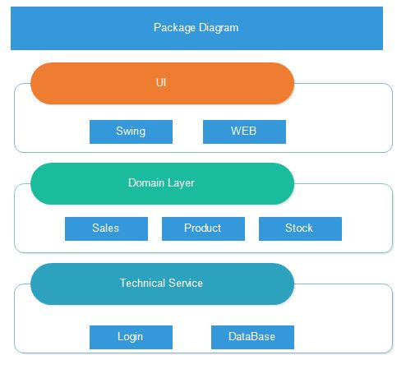

***7)System Sequence Diagram***

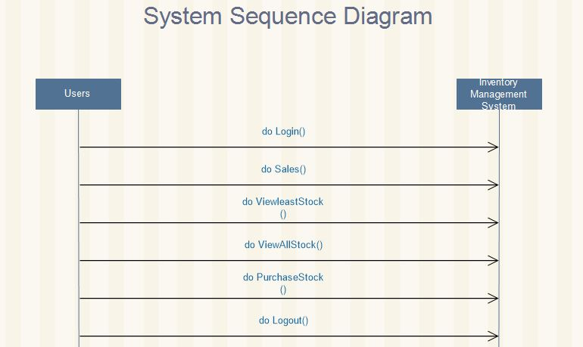

***8)Domain Class Daigram:***

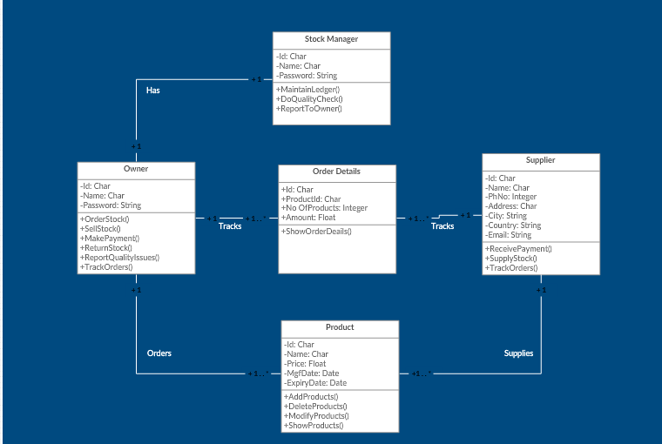

***9)Domain Model:***

